Complex Report in Cognos
Join – GL Dept Detail Tree – Repeater – Expressions – Master/Detail

We will create a report that returns non-college “17” Purposes with Ending Fiscal Balances not equal to zero for a given Fiscal Year and Period, along with the unit and administrative owner and the approvers on each code.

This report:
- Uses the GL Department Detail Tree to display the units that “own” each Purpose code with an expression that lists the specific tree “levels’ to be included
- Has three queries with one join
- Has a Repeater for the Purpose approves that is added to the List as a Master Detail relationship

- Open Report Studio using UD Financial Data Mart (in FDM packages)

- Click Create a new report or template
- Double-click the List icon

- Click Query Explorer on the Explorer Bar (click Yes on the pop-up)

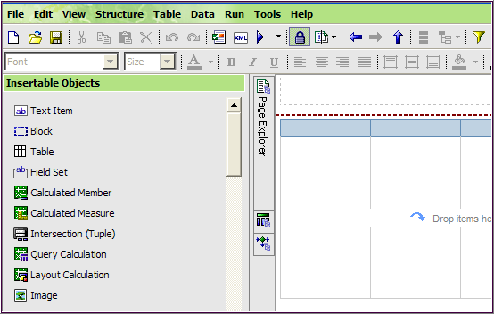
Query Explorer

- Click Queries

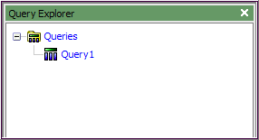

- From Toolbox, add three additional Queries

- Rename them in Properties, Miscellaneous/Name:
  - List Report
  - Balance Data
  - Fin Row Sec Data
  - Approver Repeater

- Save the report in My Folder and name it Complex Report tree data

Balance Data query

- Open the Balance Data query; add these 9 fields to the Data Items pane:

Query Subject | Folder | Field Name
Balances |  | CHARTFIELD1
Chart of Accounts | Purpose | PURPOSE_DESCR
Balances |  | AVAILABLE_BALANCE
Balances |  | UOD_END_FISC_BAL
Balances | Dates | FISCAL_YEAR
Balances | Dates | ACCOUNTING_PERIOD
GL Department Detail Tree |  | LEVEL03_DESCR
GL Department Detail Tree |  | LEVEL04_DESCR
Chart of Accounts | Purpose | SELFSUPP_PURPOSE

- Create 3 new Data Items

- From the Toolbox, drag & drop a Data Item under the SELFSUPP_PURPOSE field
  - In the Data Items Expression window enter:

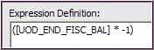

  - Validate the expression and click OK
  - Go to Properties and change the Name to End Fiscal Balance

- Get another Data Item and drop it under End Fiscal Balance field
  - In the Data Items Expression window enter:

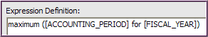

  - Validate the expression and click OK
  - Go to Properties and change the Name to Max Acctg Period

- Get another Data Item and drop it under Max Acctg Period field
  - In the Data Items Expression window enter:

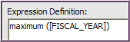

  - Validate the expression and click OK
  - Go to Properties and change the Name to Max Fiscal Year
- Add 2 pre-written prompts to the Detail Filters pane (from the Source tab)
  - Fiscal Year
  - Accounting Period

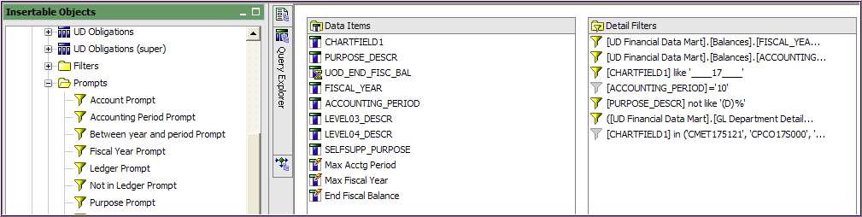

- Add the following 4 filters by clicking & dragging the appropriate Data Item to the Detail Filters pane. This will open the Expression window
Claudia, substitute: 11 for 17

(Remember to Validate each one).

  - [FISCAL_YEAR]= [Max Fiscal Year]

  - [CHARTFIELD1] like '____17____' ( _ is a wildcard and placeholder)

  - [PURPOSE_DESCR] not like '(D)%' (% is a wildcard)

  - ([UD Financial Data Mart].[GL Department Detail Tree].[LEVEL04_DESCR] in (' ', '1743 HOLDINGS LLC', 'ASST PROV STU SVCS & REGISTRAR', 'ATHLETICS PLACEHOLDER', 'COMMUNIC/MARKETING PLACEHOLDER', 'DEPUTY PROVOST', 'DEVELOPMENT AND ALUMNI REL', 'EXEC V/P OTHER', 'GRADUATE & PROFESSIONAL EDUC', 'LIBRARIES PLACEHOLDER', 'OFC OF EXEC VICE PRESIDENT', 'OFFICE OF THE PROVOST', 'RESEARCH OFFICE', 'UNIV MUSEUM PLACEHOLDER', 'UNIVERSITY WIDE', 'VICE PRES & GENERAL COUNSEL', 'VICE PRES & UNIV SECRETARY', 'VICE PRESIDENT ADMINISTRATION', 'VICE PRESIDENT FOR FINANCE', 'VICE PRESIDENT INFO TECH', 'VICE PRESIDENT STUDENT LIFE', 'ASSOC PROV ENROLLMENT SVCS') or [UD Financial Data Mart].[Balances].[CHARTFIELD1] in ('CMET175121', 'CPCO17S000', 'HNES175112', 'MAST175177', 'HNSC17S511', 'HNES17S000'))
Hint – Copy this expression from a report with the same name in Public Folders/Ellen Training /Reports for Class. Go to the Balance Data query and double-click the Detail Filter. Highlight the text, copy it and go back to your report and paste in the expression window. Validate!

For Linda only, add this Detail Filter instead of item d.:
([UD Financial Data Mart].[GL Department Detail Tree].[LEVEL04_DESCR]
= ‘AGRICULTURE & NATURAL RESOURCES’

- Add a temporary filter to verify the query’s data is good

  - Drag [CHARTFIELD1] to the Detail Filters; add this Expression:
Claudia, substitute: ‘REGI110000’

Linda, substitute: ‘AGCM175111’

[CHARTFIELD1] in ('CMET175121', 'CPCO17S000', 'GRAD175117')

  - In the menu, click Run/View Tabular Data
  - After you get good data, disable the temporary filter
    - Go to Properties/General/Usage
    - Change Required to Disabled
Fin Row Sec Data query

- From Query Explorer, open the Fin Row Sec Data query; add all 9 fields* to the Data Items pane:

Query Subject | Folder | Field Name
FIN Row Security |  | Header Tbl View OPRID
FIN Row Security |  | Header Tbl APPROVAL_OPRID
FIN Row Security |  | Header Tbl Approve All Access
FIN Row Security |  | Header Tbl View All Access
FIN Row Security |  | Row Level OPRID
FIN Row Security |  | Row Level Approver/Viewer Flag
FIN Row Security |  | Row Level CHARTFIELD1
FIN Row Security |  | Operator ID
FIN Row Security |  | Operator ID Descr [name]

* Hint: Add all the fields at once by clicking on FIN Row Security and dragging it to the Data Items pane.

- Add one Detail Filter:

  - [Row Level Approver/Viewer Flag] = 'Y'

- Add one temporary Detail Filter to verify the query’s data is good

  - [Row Level CHARTFIELD1] = 'BUDG110000'
  - In the menu, click Run/View Tabular Data
  - After you get good data, disable the temporary filter
    - Go to Properties/General/Usage
    - Change Required to Disabled

Approver Repeater query

- From Query Explorer, open Approver Repeater query and again add all 9 fields by clicking on FIN Row Security and dragging it to the Data Items pane

- Add two Detail Filters:

  - [Row Level Approver/Viewer Flag] = 'Y'

  - [Row Level OPRID]<>'Approve_All'

- Add one temporary Detail Filter

  - [Row Level CHARTFIELD1] = 'BUDG110000'

  - In the menu, click Run/View Tabular Data
  - After you get good data, disable the temporary filter
    - Go to Properties/General/Usage
    - Change Required to Disabled

Query Join

- Create the Join:
- Click Query Explorer and click Queries
- From Toolbox, drag & drop a Join next to the List Report query
- Drag the Balance Data query to the top spot
- Drag the Fin Row Sec Data query to the bottom spot
- Double-click the Join
- Click New Link
- Make the link between Chartfield1 and Row Level CHARTFIELD1
- The Cardinality is 0..n = 1..n and click OK

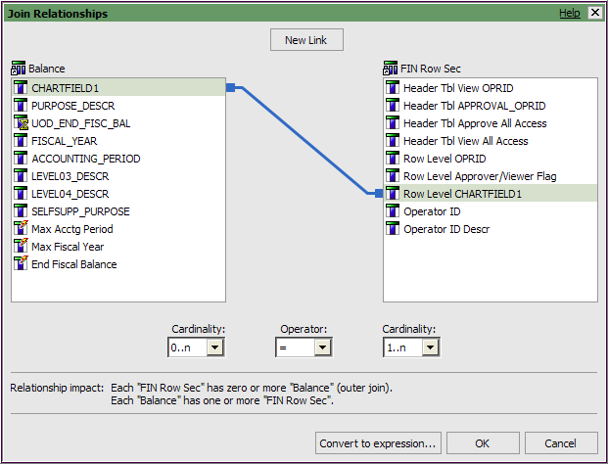

- Save

List Report query

- From Query Explorer, open the List Report query; add the following 14 fields:

Query | Field Name | Change Name to: | Change Aggregate Properties
Balance Data | CHARTFIELD1 | Purpose
Balance Data  Hint: Select these 10 fields and drag them as a group to Data Items | PURPOSE_DESCR | Purpose Description
Balance Data | AVAILABLE_BALANCE | Available Balance | yes
Balance Data | UOD_END_FISCAL_BAL |  | yes
Balance Data | FISCAL_YEAR
Balance Data | ACCOUNTING_PERIOD
Balance Data | LEVEL03_DESCR | Owner
Balance Data | LEVEL04_DESCR | Admin Unit
Balance Data | SELFSUPP_PURPOSE | Self Supporting
Balance Data | End Fiscal Balance |  | yes
Fin Row Sec Data | Operator ID | User ID
Fin Row Sec Data | Row Level OPRID
Fin Row Sec Data | Row Level CHARTFIELD1
Fin Row Sec Data | Operator ID Descr | Approvers

- Change the names of 8 fields as shown above in table
  - Go to Properties/Data Item
  - Change the Name
- Change the aggregate settings for the three fields indicated in the table on the previous page:

  - Go to Properties/Data Item
  - Aggregate Function – change from Automatic to None
  - Rollup Aggregate Function – change from Automatic to None
  - Notice these 3 field icons have changed to

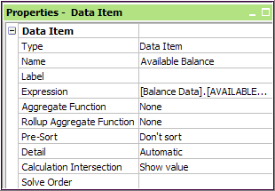

- Add the following Detail Filter:

  - [End Fiscal Balance]<>0.00

- Save

- Open Page Explorer and click Page 1 (the List will be empty)
- From the Data Items tab, add the following 8 fields from the Report List query the List:
  - Purpose
  - Purpose Description
  - Owner
  - Admin Unit
  - Available Balance
  - UOD_END_FISCAL_BAL
  - End Fiscal Balance
  - Self Supporting

- From the Toolbox, drag & drop a Repeater into the List after Admin Unit

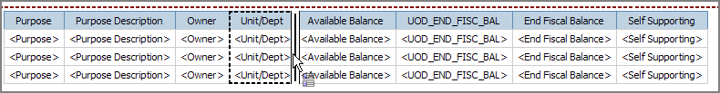

- Click the Repeater column where it says “Drop items here…”
  - Go to Properties/Data/Query
  - Change Query1 to Approver Repeater
- Change column heading of Repeater to “Approvers”
  - Clixk the Repeater column heading
  - Go to Properties/Text Source
  - Text – change to Aprpovers

- Add the field that will repeat:
  - Click the Data Items tab
  - Scroll down to the Approver Repeater query
  - Drag & drop Operator ID Descr into the Repeater where it says “Drop items here to create repeating items”

- Make the Repeater more readable by adding space between the values
  - From the Toolbox, drag & drop a Text Item next to <Operator ID Descr>

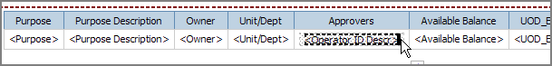

  - Type [space] [space] [space] and click OK

- Establish the Master-Detail relationship between the Repeater and the List

- Click within the Repeater cell
- Go to Properties (it should say Text Item)
- Use the Ancestor button to select Repeater
- In the Data category click Master Detail Relationships and click the Ellipses
- Click New Link
- Link Purpose to Row Level CHARTFIELD1 and click OK

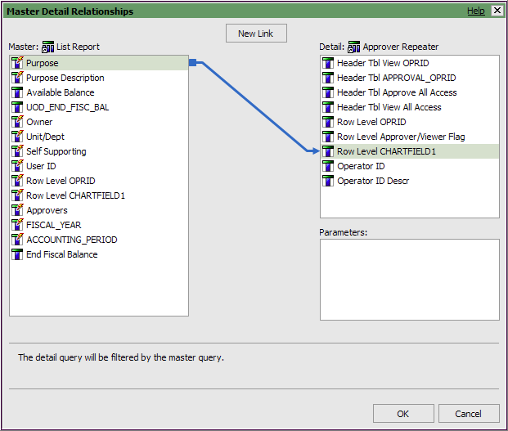
- Save

- Change the report header

- Double-click the default title and type University of Delaware
- From the Toolbox, drag & drop a Table under the title
  - Make the Table 1 column and 3 rows

- From the Toolbox, drag & drop a Text Item into the top table cell
  - Type: “17” Balance Reference List
  - Increase Font size to 12pt

- Drag & drop another Text Item into the middle table cell
  - Type: Excludes Colleges

- Drag & drop a third Text Item into the bottom table cell
  - Type Fiscal Year[space] [space]

- From the Toolbox, drag & drop a Layout Calculation next to Fiscal Year
  - In the Expression window, click the Parameter tab
  - Double-click the Fiscal Year prompt
  - Click OK

- Drag & drop another Text Item next to <ParamDisplay>
  - Type: Period[space] [space]

- Drag & drop a Layout Calculation next to Period
  - In the Expression window, click the Parameter tab
  - Double-click the Accounting Period prompt
  - Click OK

- Save

- Run the report

